Table of Contents

Teacher Data 1

Teacher Email ID should be Unique 1

Use default image if profile picture is not provided 1

Teacher Subject should be no more than 5 2

Filter Teacher by Last name or Subject 3

Bulk Import 3

# Teacher Data

Python code to handle each teacher record:

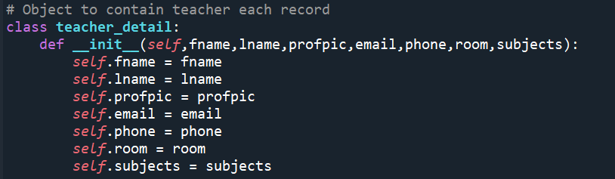

SQLite database table Teachers:

CREATE TABLE teachers ( firstname varchar(10), lastname varchar(10), profilepic BLOB NOT NULL, email varchar(50), phone varchar(15), roomno varchar(5), subjects varchar(100));

# Teacher Email ID should be Unique

The function declared check_teacher_in_db which checks the uniqueness of email id.

If some more amended conditions to be checked then line number 58 can be used based on requirement

# Use default image if profile picture is not provided

This has been handled in function check_photo_to_blob.

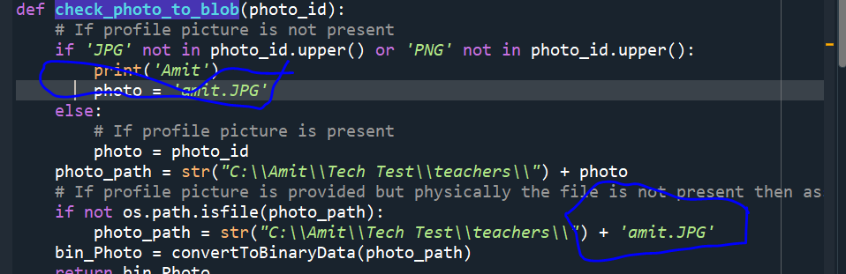

The same is working fine as below:

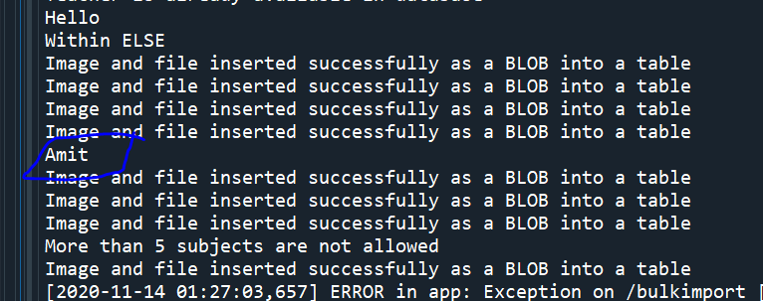

# Teacher Subject should be no more than 5

Before insertion of data it checks number of subjects in line number 183 and 146 by calling check_if_5_subs.

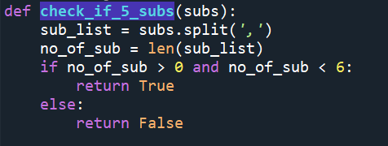

The checks are working fine while inserting bulk record as below:

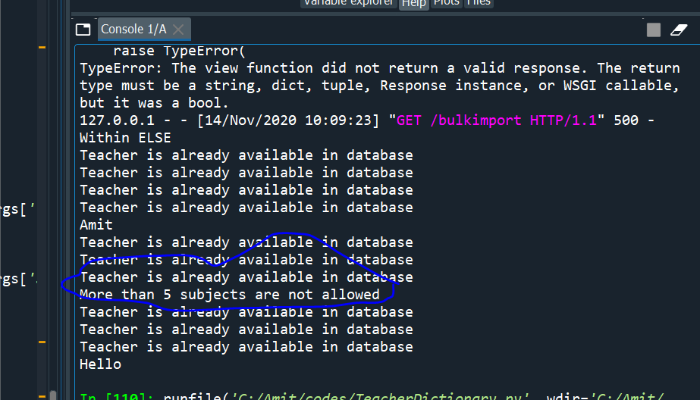

# Filter Teacher by Last name or Subject

Route /searchteacher has been created for this.

Last name starting character is checked in line number 222 and subject is checked in line number 226

Which calls then search_teacher_result to get the list of teachers with detail profiles.

# Bulk Import

This has been handled in route /bulkimport at line number 108 which takes CSV file as input and process as per requirements by calling respective functions/methods.

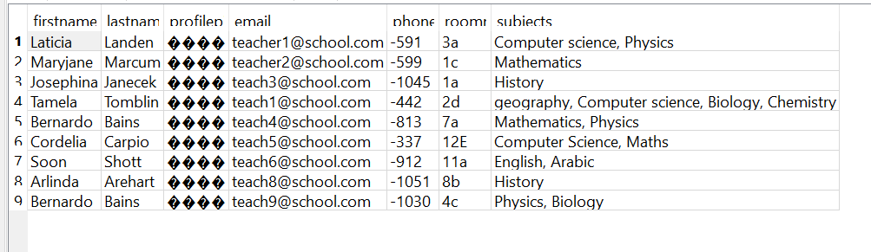

# Changes required for portability

1. Change your own DB file path in line number 98
2. Default images path and file name to be changed in 42, 46 and 49
3. Line number 118 is created for default run with bulk insert

# Click on Teacher profile to get detail

This is not coded as need some more detail about what information are passed from front end.